**Smart parking system**

**IOT_Phase4**

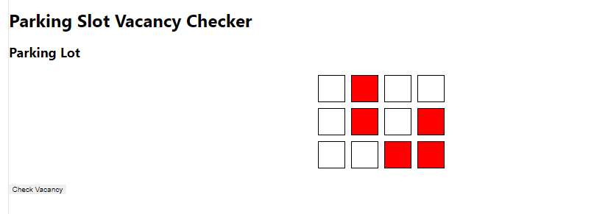

* This smart parking system is used to find the empty slots in the parking

*Red boxes are the filled slot of the parking

*White boxes are the empty slots of parking

**HTML**

<!DOCTYPE html>

<html>

<head>

<title>Parking Slot Vacancy Checker with Animations</title>

<link rel="stylesheet" type="text/css" href="style.css">

</head>

<body>

<h1>Parking Slot Vacancy Checker</h1>

<div class="parking-lot">

<h2>Parking Lot</h2>

<div class="row">

<div class="slot empty"></div>

<div class="slot occupied"></div>

<div class="slot empty"></div>

<div class="slot empty"></div>

</div>

<div class="row">

<div class="slot empty"></div>

<div class="slot occupied"></div>

<div class="slot empty"></div>

<div class="slot occupied"></div>

</div>

<div class="row">

<div class="slot empty"></div>

<div class="slot empty"></div>

<div class="slot occupied"></div>

<div class="slot occupied"></div>

</div>

</div>

<button onclick="checkVacancy()">Check Vacancy</button>

<script src="script.js"></script>

</body>

</html>

**CSS**

/* style.css */

.parking-lot {

margin-bottom: 20px;

}

.row {

display: flex;

justify-content: center;

align-items: center;

}

.slot {

width: 50px;

height: 50px;

border: 1px solid black;

margin: 5px;

transition: background-color 0.5s;

}

.empty {

background-color: white;

}

.occupied {

background-color: red;

}

**JAVA SCRIPT**

// script.js

function checkVacancy() {

var slots = document.getElementsByClassName('slot');

var count = 0;

for (var i = 0; i < slots.length; i++) {

if (slots[i].classList.contains('empty')) {

slots[i].style.backgroundColor = 'limegreen'; // Animated change of background color

count++;

} else if (slots[i].classList.contains('occupied')) {

slots[i].style.backgroundColor = 'orange'; // Animated change of background color

}

}

setTimeout(function() {

alert('Number of vacant parking slots: ' + count);

// Reset slot colors after alert

for (var i = 0; i < slots.length; i++) {

slots[i].style.backgroundColor = '';

}

}, 1500); // Delay before showing the alert (1.5 seconds)

}

**Circuit and working**

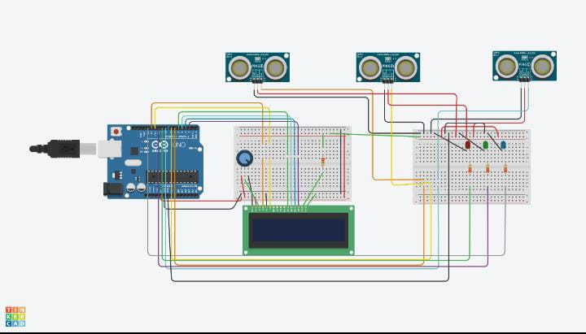

**Slot booking**

